THMEMK1105

T.H.E.M.

**ENEWSLETTER: “DIRECT TO MOUTH” Story**

01/03/2012

**Final Copy**

**(per 12/28 NK Comments)**

**HEADLINE:**

**The next big thing in packaging?**

**It's right on the tip of your tongue.**

**COPY:**

Brand managers and packaging engineers call it DTM dosing. We call it the stick pack's latest contribution to the evolution of product delivery.

DTM is the acronym for direct-to-mouth product delivery. Whether it's a dose of an OTC or Rx

Medication, or an otherwise consumable product, people want to enjoy them in a more convenient form. As long as it doesn't have to be premixed, a product can be offered in a DTM stick pack - be it dry or liquid.

You simply open the stick pack, open your mouth, and pour the product in. Just think Pixie Stix, the colorful granular candy that's been around for years. It was the first DTM stick pack product to make it big. The achievements of Pixie Stix and the numerous other brand success stories that have followed are clear indications of stick pack’s versatility and potential.

The energy product category has been one of the first to cash in, along with OTC line extensions from Reckitt Benckiser and cold and flu remedies from GSK. The Swiss firm, Mepha, was also one of the early adapters of DTM stick pack technology for its children's malaria treatment.

So what's so big about this latest use of the stick pack? What's driving the popularity and proliferation of DTM products?

• They're low profile and portable, so they travel easily.

• They're fast, with no mixing required.

• There's no spoon to wash, or solid container to dispose of and no glass, metal or plastic, just a

small, empty pouch to throw away.

• Both immediate and time-release product formulas can be delivered in DTM form.

• DTM stick packs allow for robust dosing and deliver products in a more flavorful form.

Among the growing number of companies riding the mounting wave of DTM popularity is Encaff Products. They have a line of DTM delivered energy products that is quickly gaining traction in the U.S. and abroad.

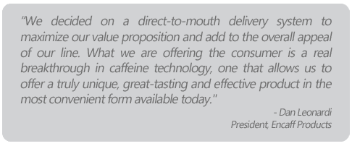

This, from a company president with over 30 years of CPG experience at giants like Pepsi and Kellogg's. And Encaff's caffeine sticks are already a commercial success at retail, with distribution through Best Buy, Tom Thumb (Kroger Division), Duane Reade and Casey's General Stores with distribution coming at leading retailers like Race Trac, Home Depot FUEL and Kum n Go. Even more impressive is the fact that the number of retail distribution points and worldwide availability of the Encaff product line is about to reach explosive proportions according to Leonardi.

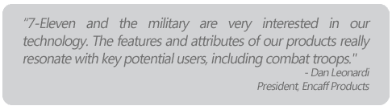

Although DTM stick packs are a natural for hundreds of consumer products in dozens of categories, they could be game-changers in the OTC and Pharmaceutical arenas. An orally dissolved tablet (ODT) typically allows for about 200mg of formulation, while a DTC stick pack can deliver 1000mg of product in less time, with consumer-friendly flavor, in the same single dose.

Another advantage of DTM over ODT is the elimination of unwanted additives in the formulation; specifically the binders, disintegrants and lubricants that are necessary for ODT ingestion.

As the benefits of DTM over ODT become increasingly apparent to consumers - the advantages of better taste and faster delivery in both immediate and time-release products, a significant paradigm shift toward DTM stick pack by a wide range of brand owners is becoming increasingly likely going forward.

The explosion in consumer demand for DTM packaging won't be limited to dry products, either. Liquid formulas will be the next category to see pioneering initiatives. As Pixie sticks are to dry products, Go-Gurt is a good example of things to come for liquids. The drivers for major expansion, like dry DTM, are rooted in convenience, portability and taste. And liquid products have the same broad market potential as solid products, from confectioneries to OTC and even the mighty pharmaceuticals.

So don't think too hard when someone asks you what the next big thing in packaging will be. The answer may be right on the tip of your tongue.

To learn more, speak with Steve Belko today at 800.322.8436 or [contact us](http://www.them.net/contact-direction).